Chapter 18, Problem 10.

Obtain the Fourier transforms of the signals shown in Fig. 18.35.

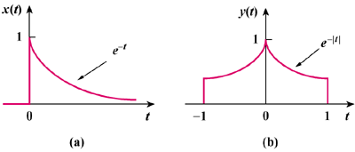

Figure 18.35
For Prob. 18.10.

